1. 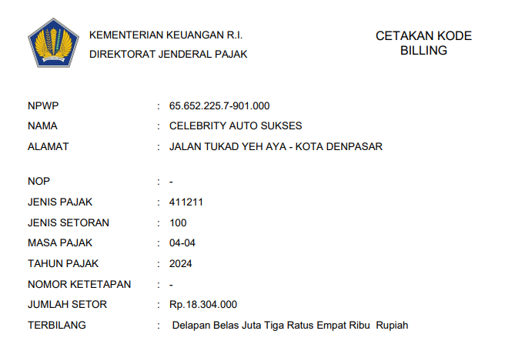PPN 1.1%
2. FEE KONSULTAN PAJAK

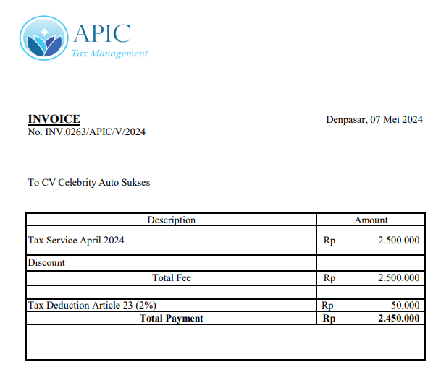

1. ANGSURAN PPH FINAL

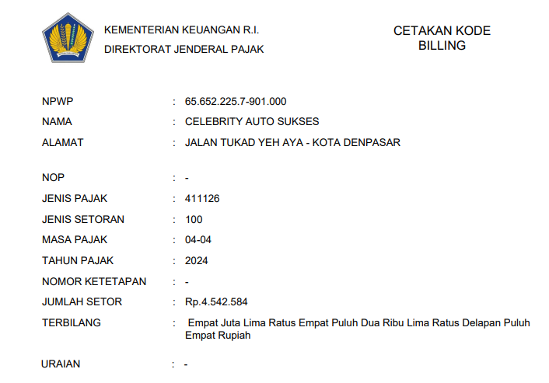

5.PATTY CASH

